GOVERNMENT DEGREE COLLEGE-TEKKALI
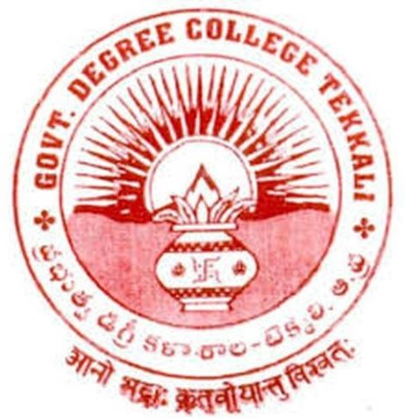
(Affiliated to Dr.B.R.Ambedkar University,Etcherla,Srikakulam)

DEPARTMENT OF CHEMISTRY INDUSTRIAL VISITS / FIELD TRIPS

Objectives : 1. To acquaint with various instrumentation such as chromatographic techniques,NMR,IR,UV-Visible spectrophotometer etc.
- To impart training and allow the students to visit various departments such as process of manufacturing,safety,Quality control(QC) and Quality assurance etc.
- To create interest among students towards placements in Pharma industries.
Outcomes : 1. Students underwent acquaintance with the instrumentation, process of manufacturing,safety,QA and QC etc.
2. Students got a complete information about how a drug is manufactured in a Pharma industry.

S.No. | Date | Name of the industry visited | Number of students  attended | Name(s) of faculty attended | Remarks
1. | 05-03-2018 | Aurobindo Pharma ltd; Pydibhimavaram, Srikakulam District | 31 | D.Adinarayana T.Chandra Sekhar B.Parvathi
2. | 22-02-2020 | Aurobindo Pharma ltd; Pydibhimavaram, Srikakulam District | 16 | D.Adinarayana M.Bala Krishna P.V.Satyanarayana T.Chandra sekhar  Ch.Sunitha

SUPPORTING DOCUMENTS
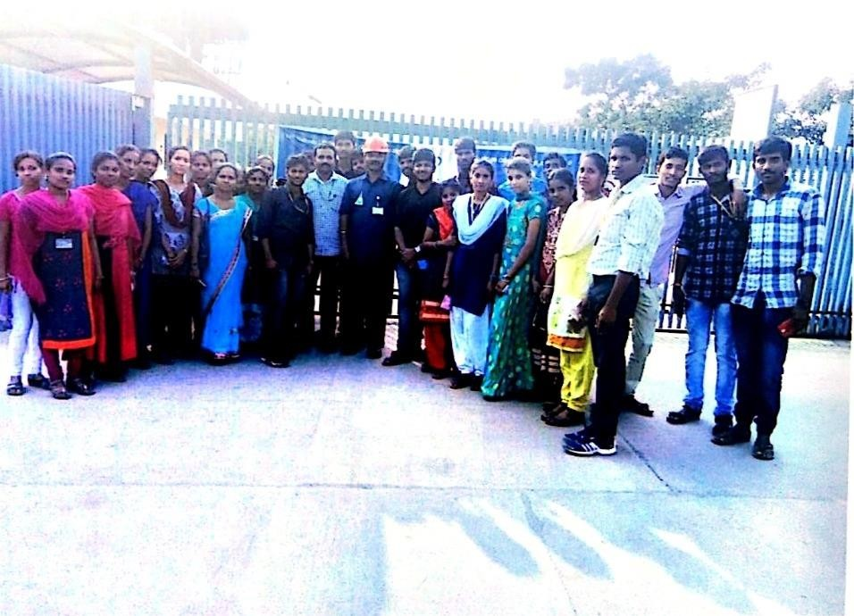
Visited Aurobindo Pharma ltd; on 05-03-2018

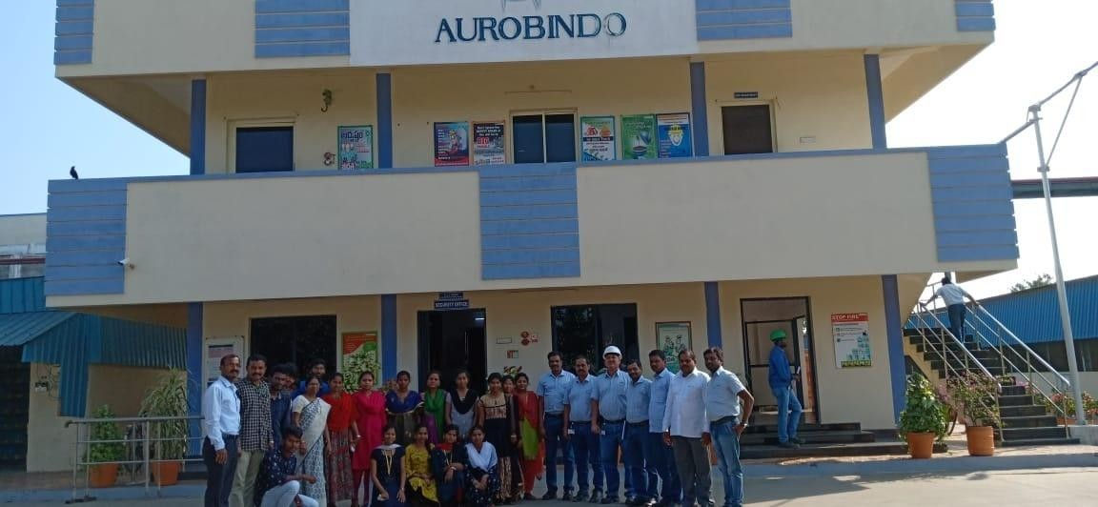

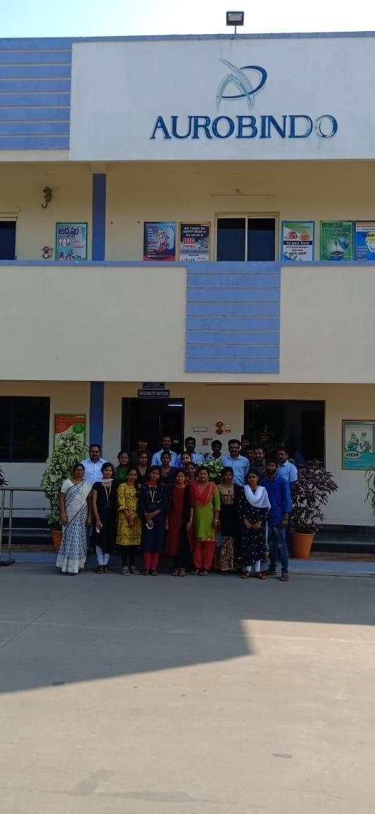
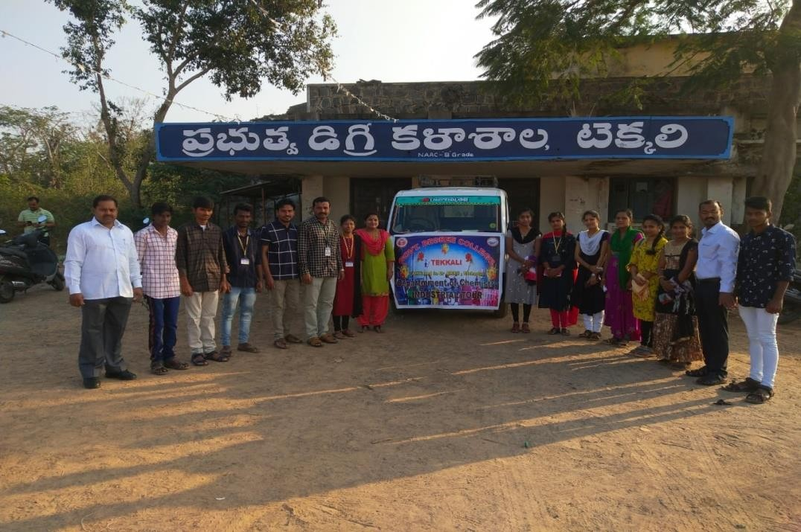
Visited Aurobindo Pharma ltd. on 22-02-2020

